Wise Words: National Teams
Gary Wise
Every four years, the biggest sport-specific athletic event in the world, the World Cup of Football (soccer) is held, and despite my complete and utter ignorance of the nuances of the game, I can't tear myself away from the television whenever it's on because of the power generated by the combination of competition and patriotism. It's war without death, and it's glorious.
Right now, as Europeans Patrick Mello and Kai Budde watch me write this, they're smirking a little as they wouldn't put their feelings about that tournament in such flowery language, at the same time understanding that I can't possibly comprehend the importance of that tournament being from this side of the Atlantic, but I really do appreciate the importance of the World Cup: it's the best each country has to offer bringing their respective cultures to the field of athletic battle, with a loss suggesting their diminishment. And so it is with Magic.

This weekend is World Championships, easily the greatest event of the Magic calendar, thanks to the competition that sends each nation's Magic community scurrying to produce a team of their finest in order to compete with one another. At the end of it all, one of those teams will emerge victorious, and as with the World Cup, that team's country as well.
This year's batch of National Championships produced a number of surprises, from the former Pro Tour player who won the last National event of them all to the Canadian who came out of nowhere to win a European nation's championship to the fact that not one player in the Top 15 of this year's Player of the Year race made their National team. This year's competition, which has been won every year but one by the United States, is as open as any in history, and your guess is as good as mine as to who will emerge victorious.
This week's Wise Words looks at past team competitions and the nations competing for this year's title. Use it as a resource to refer to when following Worlds here on Sideboard, and enjoy the festivities from Toronto.

A Long Time Ago in a Galaxy Far, Far Away (Seattle)...
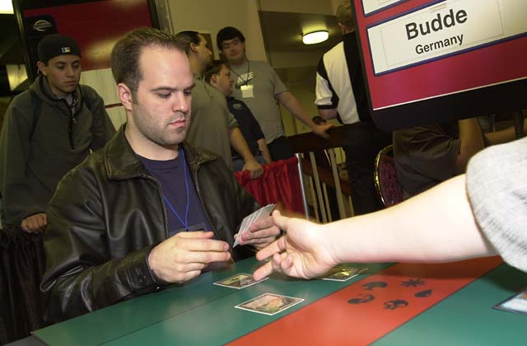
The team competition started with the event that would set the pattern for years to come. The first U.S. Team was a classic, composed of the incredible foursome of George Baxter (Top 8, PT-NY1), Matt Place (Champion, PT-Mainz), Mike Long (Champion, PT-Paris) and their team captain, Dennis Bentley (1996 U.S. National Champion). The U.S. cruised to victory in a time when North American Magic was far more developed than that in the other regions of the globe, so the sheer strength of that team was probably overkill more than anything else.
In 1997, The U.S. lost the title they'd regain the next year and hold until the present. Team Canada, led by Gab Tsang, who finished 5 points ahead of the field in the Swiss portion of the tournament and National Champion Gary Krakower defeated a Swedish team in the finals that included PT mainstay Mattias Jordstedt and Nicolai Weibul, who finished in the Top 8 of the singles competition that year. The U.S. team, composed of then unheralded National Champion Justin Gary, future Player of the Year Bob Maher, Kyle Bigos and Jeff Butz was never in the running, finishing fourth thanks to a strong finish.
In 1998, another unknown National Champion, Matt Linde, led two of the best players in the history of the game, Jon Finkel and Mike Long, along with Californian Bryce Currence to reclamation of the championship on the strength of Finkel's Top 4 finish in the Swiss. The Americans defeated the French team that included young Raphael Levy, who lost to Brian Selden in the semifinals of the tournament.
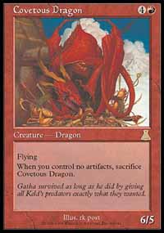
1999 saw the Americans overcome a close challenge from first-time finalists Germany. Led by Champion Kyle Rose, the U.S., who was also represented by Zvi Mowshowitz, John Hunka and Charles Kornblith (who got the spot thanks to Phoenix native Chris Tobler's decision not to go) emerged victorious in the final over Marco Blume, Patrick Mello David Brooker, Rosario Maij thanks in part to a memorable error by German Champion Blume, who played Covetous Dragon with no artifacts in play.
Last year, it was one of the stronger editions of the U.S. Team who went the distance. Led by eventual World Champion Jon Finkel, the U.S. Team that included Chris Benafel, Aaron Forsythe and Frank Hernandez, smashed through the field before meeting a team Canada led by America-beater Gab Tsang and National Champion Ryan Fuller in the final. With the final resulting in a 2-2 tie, the National Champions played in a tiebreaker match to decide the whole thing, and Finkel smashed Fuller thanks to great draws in what was already a great matchup. Their appearance in this final made Canada the only country aside from the U.S. to make two finals.

A New Hope...
With history firmly entrenched on the side of the Americans, all focus rests on their broad shoulders when the team championship is announced. It seems like the competition has become one of America vs. the world, so U.S. Nationals is closely watched to see who will be representing WotC's home country this time around, and whether there might be a chink in their armor.
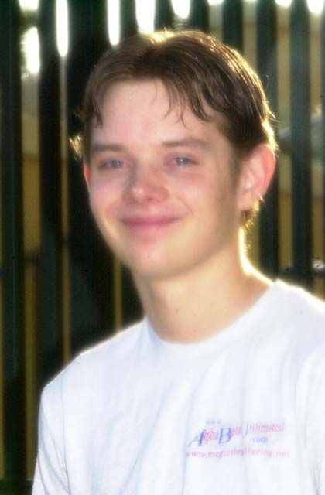
The U.S. team this year is according to some the weakest ever, with two relative unknowns breaking out in the 'toughest tournament of the year' to claim spots. Brian Hegstad, a member of team AlphaBetaUnlimited, has never made a dollar on Pro Tour, with his closest call in three tries coming in Barcelona, where he finished 67th. He does however have a number of strong finishes in American Grand Prix, with a fifth place showing in Boston and two other Top 16 finishes this year. Eugene Harvey, meanwhile, could have played in the recent Amateur Championships at origins if he desired, with no PT points on his resume. With two such unknowns, many Americans may be worried, but the one thing going for them are the important teams they'll be working with, with Harvey a full-fledged member of CMU receiving tutelage from the likes of Mike Turian and Aaron Forsythe while Chris Benafel and the like make sure Brian gets a strong deck selection.
The two newcomers will be joined by one of the most decorated participants in this year's event, Trevor Blackwell. Winner of PT-LA '99 and the U.S. Booster Challenge at last years Nationals, Trevor won the U.S. Championship in convincing fashion, defeating Hegstad 3-0 in the final. The big question with this year's competition is how the three will work together for the Team Rochester format being used in the competition, with Trevor being one of the few pros without a team for NY at present.
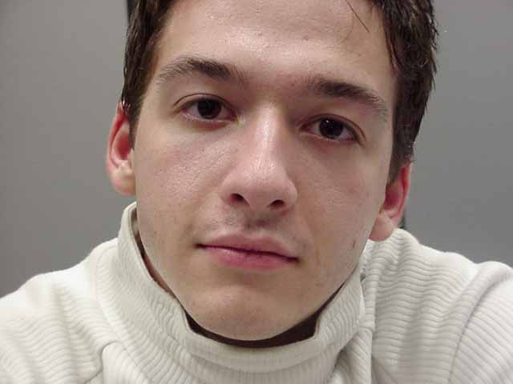
Challenges to the American throne could come from any of a number of teams. While most people seem to be talking about Canada and the Netherlands, the team that should probably scare the Americans the most is Austria. The top participant in the team event this year with regards to Pro Tour points this season is Benedikt Klauser by a long shot. Klauser has shown himself to be capable in both Limited and Constructed, proving this with a Top 4 showing at last year's Worlds followed by another Top 4 showing at PT-LA this year. Joining Ben on the team will be fellow Worlds 2000 Top 8 finisher Hemut Summersberger, giving this team as formidable a 1-2 punch as any in the competition. The weak link here appears to be Reinhard Hoelzel, a mid-twenties games enthusiast, but there's a movement in place to try to convince Hoelzel to concede his spot on the team to alternate Philip Reich, and the feeling in the Austrian camp is that if the movement is legal and successful, Austria will become the team to beat.
Meanwhile, the Dutch aren't bringing anything new to the table. Tom Van de Logt, Jeroen Remie and Frank Karsten were all members of the Dutch team that finished fourth last year, and my understanding is that they were the three strongest members of the team. Van de Logt finished fifth a year ago while Karsten finished seventeenth, but the individuals faltered in the team portion. Now with a year of experience under their belts, the three players who were good enough to emerge from a National Championship tourney that included Ryan Fuller, Noah Boeken and Kamiel Cornelissen, these three are poised to make a run at the title. The guess here is that as the erratic Van de Logt goes, so will this team.
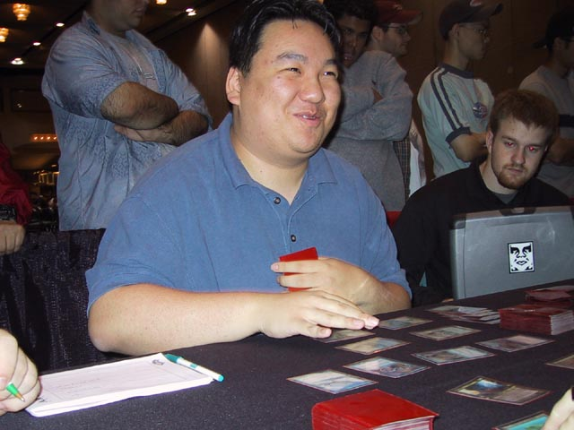
Meanwhile, across the ocean, a lot was being made of how Team Canada was shaping up midway through the tournament. With PT regulars like Gab Tsang, Terry Tsang, and I all going 5-1 or better and Gary Krakower, Mike Gurney and Matt Vienneau not far behind, a lot of people were talking about a World Championship. In the end, Canada emerged with a team that will definitely be competitive, though probably not dominant. Leading the team into the tournament will be former gravy trainer Terry Tsang. Terry, whose best finish was a Top 8 at PT-NY 3, was dominant at Championships, going 6-0 in the draft portion before going 4-2 with a game loss and a concession in the Constructed portion of the tournament. Joining Terry will be Elijah Pollack, a two-time Junior PT Top 8 finisher considered by many to be among the Top 5 players in Canada, at least when he feels like it. Terry and Elijah have been working together along with Gab Tsang towards World Championships and should have an advantage over most of the teams in the Rochester portion as a result. Their third is Sam Lount, who surprised everyone by breaking through with Fires to capture third place at Nationals.
The kings or European Championships, Norway once again sends a solid team to the table, with King Oyvind Odegaard and former European Champion Nicolai Herzog leading the way. Odegaard has appeared in six Pro Tours over the last three years, finishing in the double digits in all six, with his best finish being a 27th place showing in Barcelona. Nico meanwhile, is one of the most established players in this year's tournament, with fourteen Pro Tours under his belt, including a Top 8 finish at Worlds '99. If Bjorn Jocumsen had defeated Jan Pieter Groenhof for the third spot, this team would definitely be the favorite, with Bjorn and Nico forming two-thirds of PTNY 5th place finisher Team Outland, but Groenhof is reportedly a strong Limited player who will fill the team out nicely.
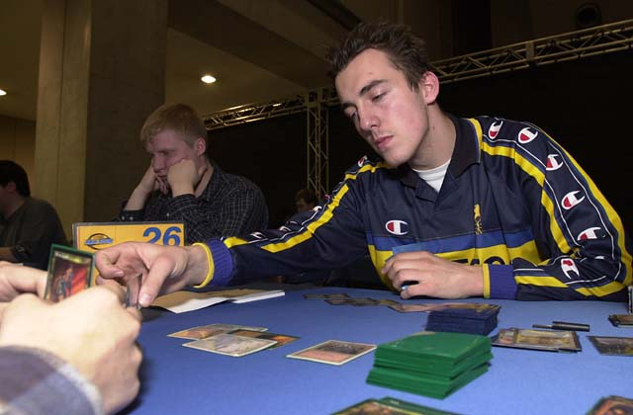
In terms of Pro Tour experience, France may have the edge on the field. Combined, Olivier Ruel, Laurent Pagorek and National Champion Pierre Malherbaud have 23 Pro Tour appearances, but the latter two have had relatively little success on the international scene. Pierre's once-promising career has taken a harsh turn over the last two years, while Pagorek has never placed in a PT Top 32, so this team will likely count on solid performances leading them to a decent spot in the standings heading in to teams day where teams Rochester specialist Oliver will hopefully guide their ascent.
Fresh off a semifinals appearance at European Championships, National Champion Tomi Walamies leads a solid team Finland to Worlds. A five-year Pro Tour veteran, the twenty year old Walamies is having what may be his best year, with two thirty-something finishes on this Pro Tour season to go with his strong European performances. Walamies will be joined by Mike Wall, a member of last year's third-place finishing team, and Jussi Perala, who playtested with Walamies, suggesting they should work very well together.
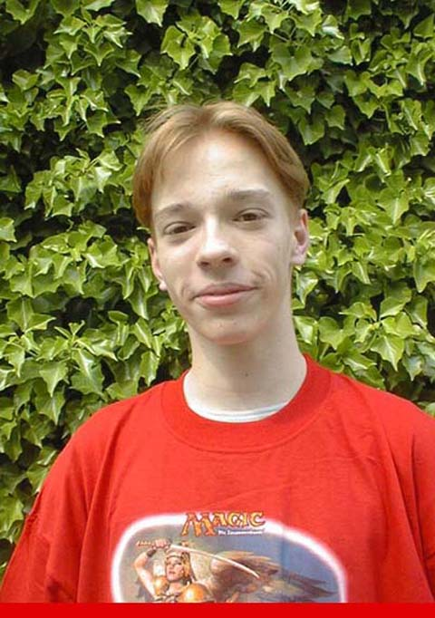
Last of the major teams in this year's competition is Germany. Headed by 17-year old Daniel Zink, the Germany look solid, though perhaps not as strong as in years past. Zink has exploded onto the scene this year, with his first Pro Tour, Barcelona, followed by his shocking win at German Nationals and a semifinals appearance at European Championships. Zink's inexperience will be balanced by the real gem on this team, Stephan Valkeyser. Stephan took a step back from Pro Tour play this year, but last year was the Tour's most consistent performer, finishing in the money at every event. Stephan started this season off with his team, Draften und Spielen finishing third at New York. Stephan's Team Rochester expertise will prove invaluable, though he could be in trouble for the Swiss portion, with no Pro Tour team to help him with deck construction. Germany's third is Mark Zeigner, a relative unknown who reportedly showed a lot of promise at the national tournament.
I'm not saying that these are the only teams that have a chance to win it all, only that they have the best chance to do so. That's about it for this week. Have a good one.

